**SPRINT-4**

|  |  |
| --- | --- |
| **Date** | 19 November 2022 |
| **Team ID** | PNT2022TMID29786 |
| **Project Name** | Smart Fashion Recommender Application |

**KUBERNETES CLUSTER :**

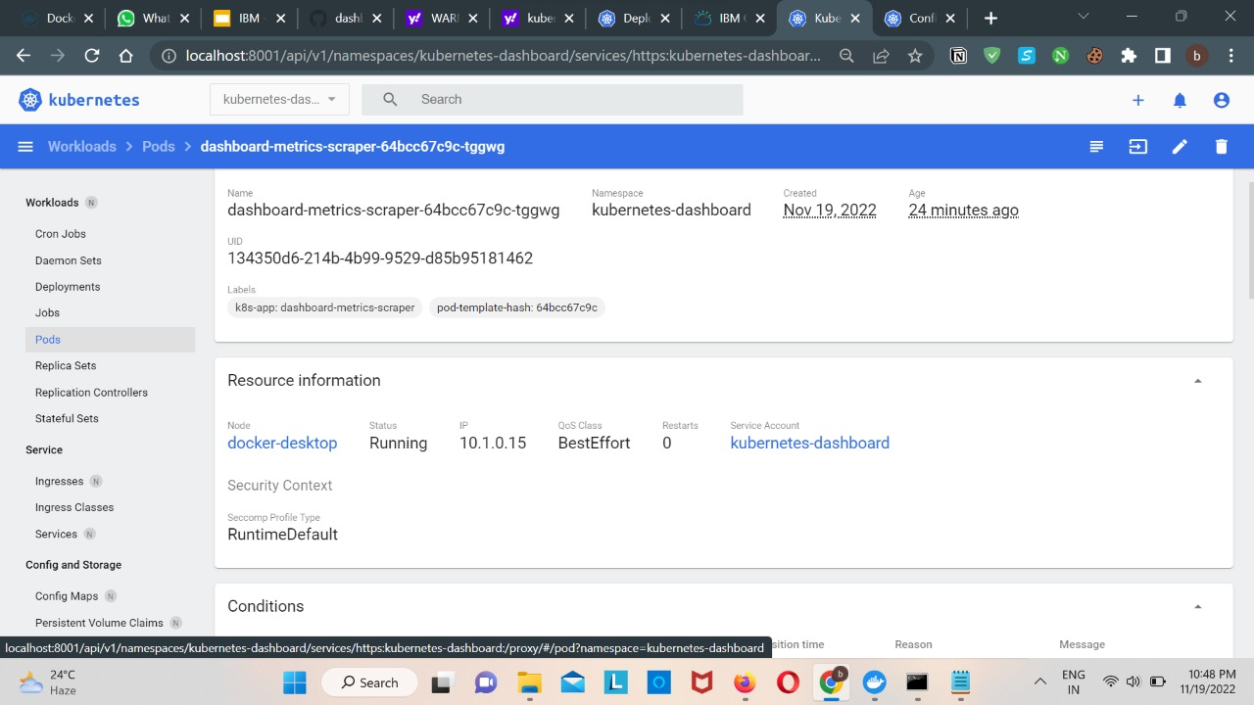

**KUBERNETE DEPLOYMENT:**

**KUBERNETE SERVICE PODS:**

